23MAT216 – Probability and Random Processes

Here’s a MATLAB script that computes the regression lines for two-dimensional random variables using the given statistical measures derived from a joint probability mass function (jpmf) or joint probability density function (jpdf).

Formulas for Regression Lines
The regression lines of Y on X and X on Y are given by:

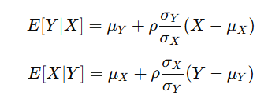
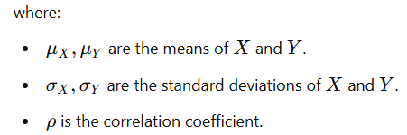
% MATLAB script to compute regression lines for two-dimensional random variables

clc; clear; close all;

% Define the joint probability mass function (jpmf) or joint probability density function (jpdf)
% Example: Joint PMF for discrete random variables
X = [1, 2, 3]; % Possible values of X
Y = [1, 2, 3]; % Possible values of Y
jpmf = [0.1, 0.2, 0.1;
0.2, 0.1, 0.1;
0.1, 0.1, 0.1]; % Joint probability mass function

% Compute marginal distributions
px = sum(jpmf, 2); % P(X)
py = sum(jpmf, 1); % P(Y)

% Compute means
mu_X = sum(X .* px');
mu_Y = sum(Y .* py);

% Compute standard deviations
sigma_X = sqrt(sum(((X - mu_X).^2) .* px'));
sigma_Y = sqrt(sum(((Y - mu_Y).^2) .* py));

% Compute covariance
E_XY = sum(sum((X' * Y) .* jpmf)); % E[XY]
cov_XY = E_XY - mu_X * mu_Y;

% Compute correlation coefficient
rho = cov_XY / (sigma_X * sigma_Y);

% Regression lines
% E[Y | X] = mu_Y + rho * (sigma_Y / sigma_X) * (X - mu_X)
EY_X = mu_Y + rho * (sigma_Y / sigma_X) * (X - mu_X);

% E[X | Y] = mu_X + rho * (sigma_X / sigma_Y) * (Y - mu_Y)
EX_Y = mu_X + rho * (sigma_X / sigma_Y) * (Y - mu_Y);

% Display results
fprintf('Mean of X: %.4f\n', mu_X);
fprintf('Mean of Y: %.4f\n', mu_Y);
fprintf('Standard deviation of X: %.4f\n', sigma_X);
fprintf('Standard deviation of Y: %.4f\n', sigma_Y);
fprintf('Correlation coefficient (rho): %.4f\n', rho);

% Plot regression lines
figure;
scatter(X, EY_X, 'ro', 'filled'); hold on;
plot(X, EY_X, 'r-', 'LineWidth', 2);
scatter(EX_Y, Y, 'bo', 'filled');
plot(EX_Y, Y, 'b-', 'LineWidth', 2);
legend('E[Y|X]', 'Regression Line Y on X', 'E[X|Y]', 'Regression Line X on Y');
xlabel('X and Y values');
ylabel('Conditional Expectations');
title('Regression Lines');
grid on;

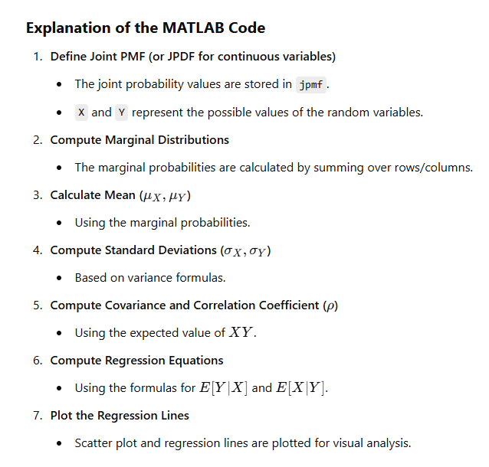
Practice Problems

- Given is the joint probabilities of X and Y.

Y  X | 0 | 1 | 2
0 | 0.02 | 0.08 | 0.10
1 | 0.05 | 0.20 | 0.25
2 | 0.03 | 0.12 | 0.15

- The joint probability mass function pmf of X and Y is
Y  X | 0 | 1 | 2
0 | 0.1 | 0.04 | 0.02
1 | 0.08 | 0.20 | 0.06
2 | 0.06 | 0.14 | 0.30
- In an automobile plant two tasks are performed by robots. The first entails welding two joints; the second, tightening three bolts. Let X denote the number of defective welds and Y the number of improperly tightened bolts produced per car. Since X and Y are each, discrete, (X, Y) is a two-dimensional discrete random variable. Past data indicates that the joint density for (X, Y) is as shown in the Table.

Y  X | 0 | 1 | 2 | 3
0 | 0.840 | 0.030 | 0.020 | 0.010
1 | 0.060 | 0.010 | 0.008 | 0.002
2 | 0.010 | 0.005 | 0.004 | 0.001

- The two common types of errors made by programmers are syntax errors and errors in logic. For a simple language such as BASIC the number of such errors is usually small. Let X denote the number of syntax errors and Y the number of errors in logic made on the first run of a BASIC program. Assume that the joint density for (X, Y) is as shown in the Table.

Y  X | 0 | 1 | 2 | 3
0 | 0.400 | 0.100 | 0.020 | 0.005
1 | 0.300 | 0.040 | 0.010 | 0.004
2 | 0.040 | 0.010 | 0.009 | 0.003
3 | 0.009 | 0.008 | 0.007 | 0.003
4 | 0.008 | 0.007 | 0.005 | 0.002
5 | 0.005 | 0.002 | 0.002 | 0.001

- Two random variables X and Y have the joint density, f(x, y) = 2 – x – y , 0 ≤ x ≤ 1, 0 ≤ y ≤ 1 ;
0 , otherwise
- X and Y are two random variables having joint density function f(x, y) = (1/8)(6 – x – y)
for 0 < x < 2 and 2 < y < 4.
- The joint probability function of two random variables X and Y is given by
f(x, y) = c(2x+y), where x and y can assume all integers such that 0 ≤ x ≤ 2 and 0 ≤ y ≤ 3
and f(x, y)=0 otherwise
- Two random variables X and Y have the joint density f(x, y) = x y, 0 ≤ x ≤ 1, 0 ≤ y ≤ 2
- The joint pdf of two random variables is given by f(x, y) = 6 exp[−2x−3y ] for x ≥ 0, y ≥ 0.

